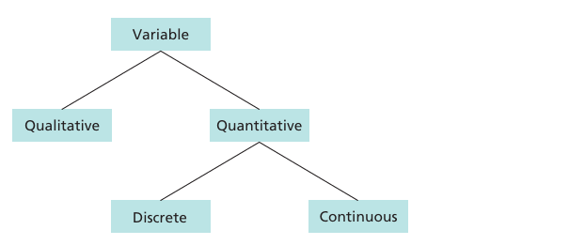
Variable
A variable is a characteristic or value that can change from one person, object, or situation to another.
Example:
Suppose we have students:
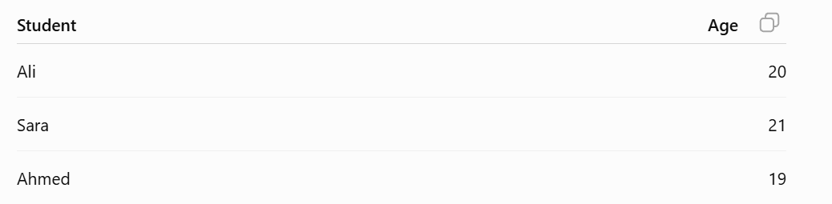
Here, Age is a variable because its value changes from student to student.
Other examples of variables:
- Height
- Weight
- CGPA
- Marks
- Blood group
- Number of family members

Qualitative Variable
A qualitative variable describes a quality or category.
Its values are usually words/categories, not numerical measurements.
Examples:
- Blood Group: A, B, AB, O
- Gender: Male, Female
- Eye Color: Black, Brown, Blue
- Department: CS, IT, SE
Quantitative Variable
A quantitative variable represents something that can be measured or counted using numbers.
Examples:
- Age: 20, 21, 22
- Height: 170 cm, 175 cm
- Weight: 60 kg, 70 kg
- Marks: 80, 75, 90
- Number of family members: 4, 6, 8
Quantitative variables have two types
1. Discrete Variable
A variable that is counted and usually takes whole-number values.
Examples:
- Number of students: 50
- Number of family members: 6
- Number of cars: 3
You normally cannot have 3.5 family members.
2. Continuous Variable
A variable that is measured and can take decimal values.
Examples:
- Height: 175.5 cm
- Weight: 65.7 kg
- Temperature: 36.5°C
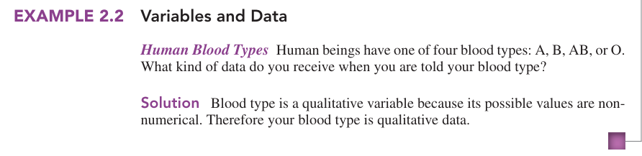
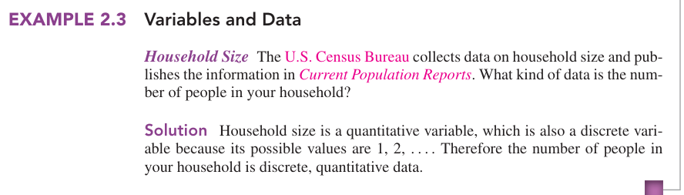
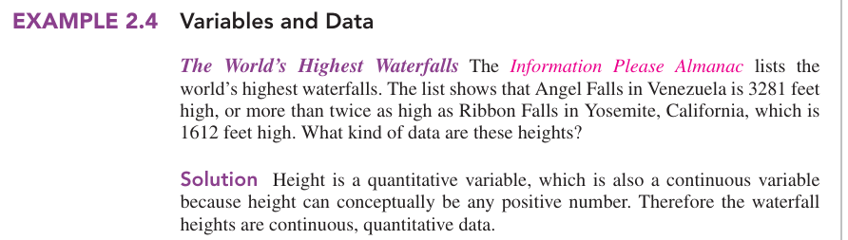
Data
Data is a collection of facts, information, or observations that are collected for a specific purpose.

Examples:
- Students' marks: 70, 85, 60, 90
- People's ages: 20, 25, 30
- Names, genders, heights, temperatures, sales, etc.
Types of Data
1. Primary Data
Primary data is the data that is collected directly by the researcher for a specific purpose.
Examples:
- Conducting a survey
- Interviewing people
- Taking measurements
- Doing an experiment
2. Secondary Data
Secondary data is data that has already been collected by someone else and is used by a researcher.
Examples:
- Government reports
- Books and research papers
- Websites
- Existing company records
3. Quantitative Data
Data that is represented by numbers and can be counted or measured.
Examples:
- Age: 20 years
- Height: 175 cm
- Marks: 85
- Weight: 70 kg
- Number of family members: 5
2. Qualitative Data
Data that represents categories or qualities and is usually expressed in words.
Examples:
- Gender: Male/Female
- Blood Group: A/B/AB/O
- Eye Color: Brown/Black
- Department: CS/IT/SE
Representation of Data
Data representation means showing or organizing data in a clear and understandable form so that it can be easily analyzed and interpreted.
1. Time Series Data
Time series data is data collected or recorded at different points in time, usually in chronological order.
Here, the same unit is observed repeatedly, while the time changes.
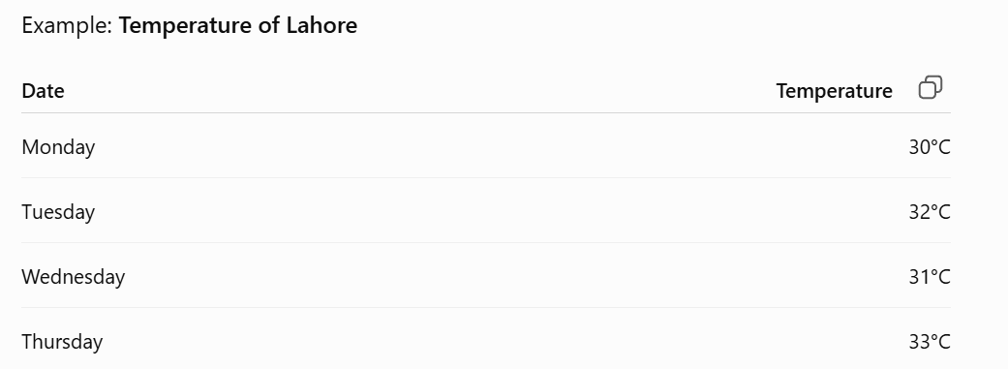
2. Cross-Sectional Data
Cross-sectional data is data collected from different people, places, or groups at the same point in time.
Here, the units change, while the time remains the same.
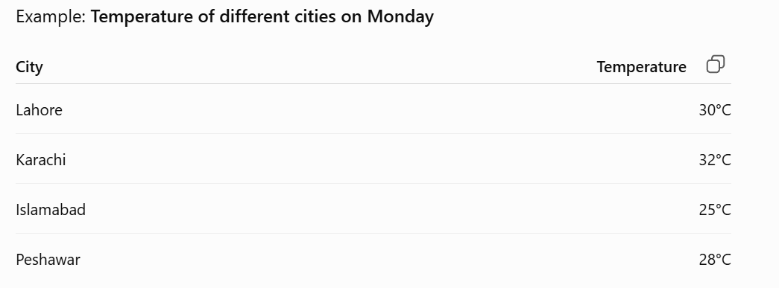

3. Panel Data
Panel data combines the features of time series data and cross-sectional data.
It collects data from multiple units over multiple points in time.
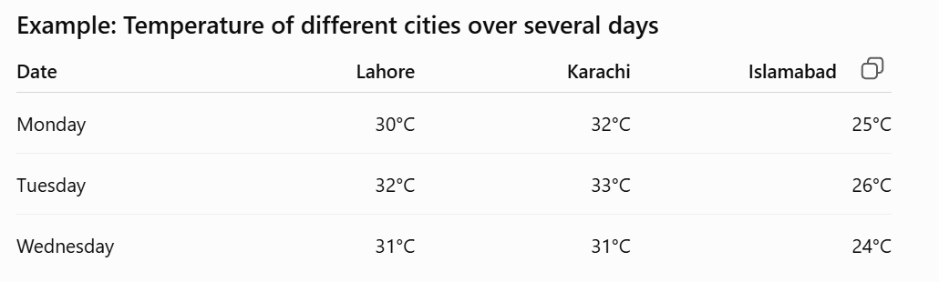

Study vs Auxiliary Variable
1. Study Variable
The study variable is the main variable that you are interested in studying or analyzing.
Example:
Suppose you want to study the average weight of students.
- Weight: Study variable
2. Auxiliary Variable
An auxiliary variable is an additional variable that helps you understand, estimate, or analyze the study variable more effectively.
Example:
Suppose you are studying students' weight:
- Weight: Study variable
- Age, height, gender: Auxiliary variables
Frequency Distribution
Frequency distribution is a table that organizes a data set into a suitable number of classes or groups and shows the frequency of each class.
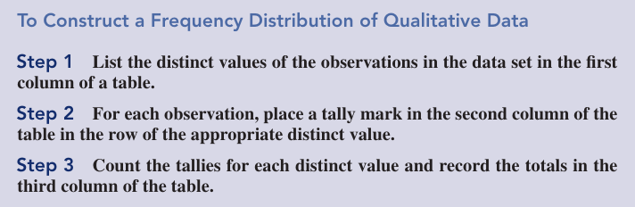
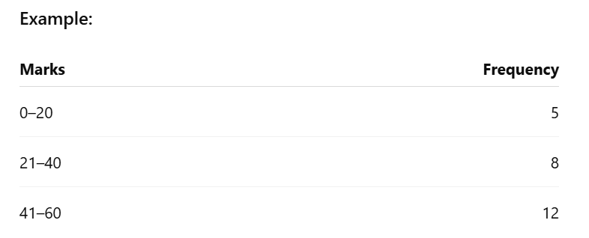
Grouped Data
Grouped data is data that is divided into groups or intervals (classes) instead of showing every individual value.
Example: Suppose students' ages are:
10, 11, 12, 13, 14, 15, 16, 17
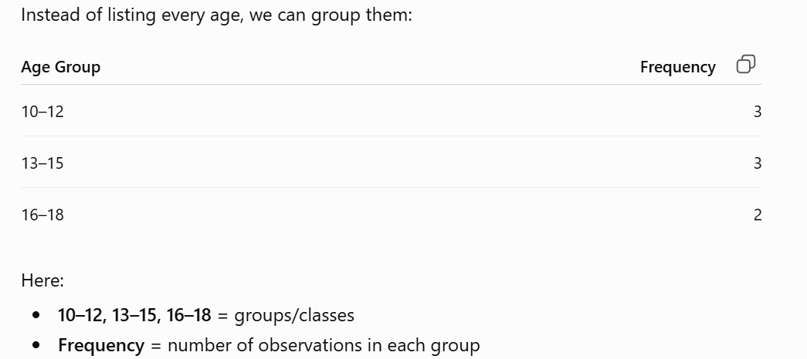
Types of Frequency
1. Percentage Frequency
Percentage frequency shows the frequency of a value or class as a percentage of the total frequency.
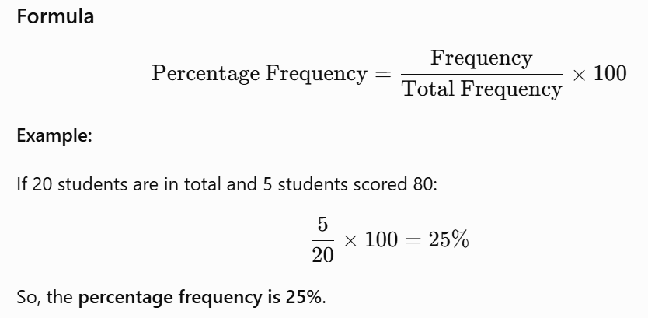
2. Cumulative Frequency Distribution
Cumulative frequency distribution is a table that shows the running total of frequencies up to each class.
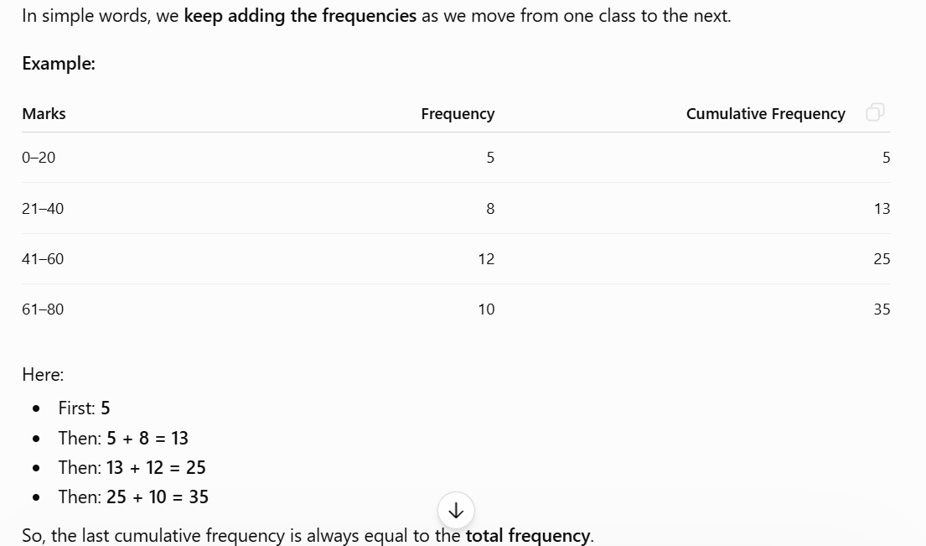

Example
